Apêndice 1- Questionário

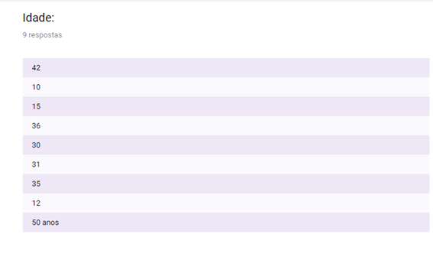
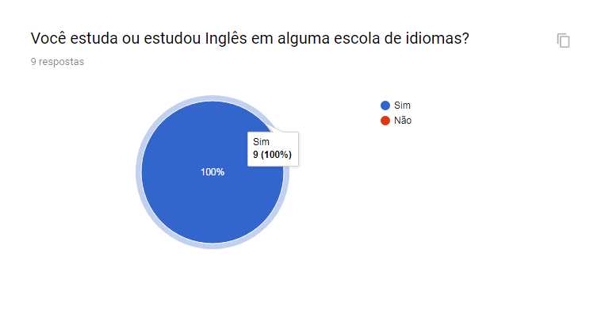
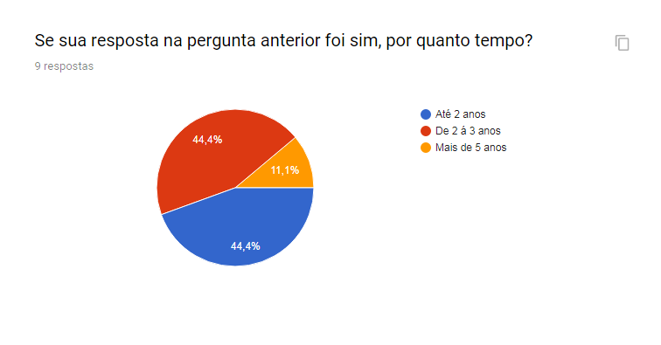
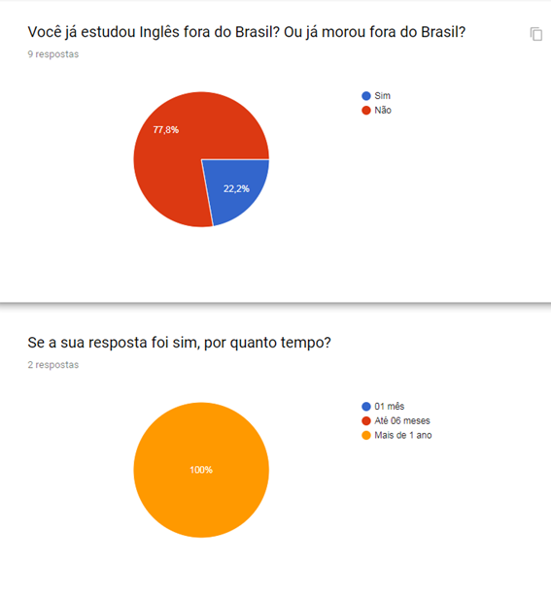
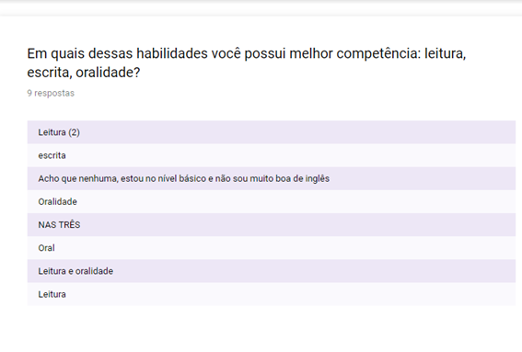
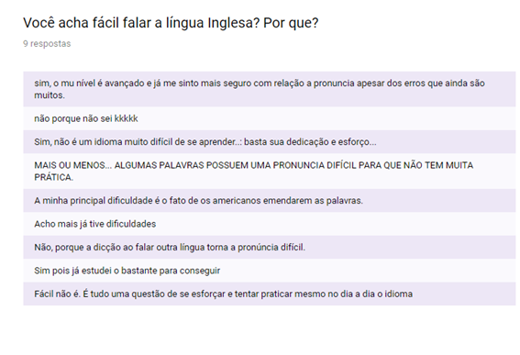

Apêndice 2- Frases da pesquisa de campo

Yesterday I visited my Family.
Yesterday I invited my parents for dinner.
Yesterday I moved to a new office.
Yesterday I arrived home early.
Yesterday I called to my friend.
Yesterday I watched TV.
Yesterday I washed my car.
Yesterday I worked too many hours.

